The Invisible Object: A meditation
Excerpt from a longer work

Bradley Ford

Grant me, Lord, to know and understand whether a man is first to pray to you for help or to praise you, and whether he must know you before he can call you to his aid. If he does not know you, how can he pray to you? For he may call for some other help, mistaking it for yours.
––Saint Augustine, Confessions

Belief has a strange way of altering gesture. Look at William Blake’s The Ancient of Days, for instance: the holy fingers of a white-haired God, his arm an arcing compass from the clouds guiding our ideas, our decisions, our lives. Look at Michelangelo’s The Creation of Adam: God creating the first man; their index fingers almost touching, but not quite. Adam is loose, uncertain, perhaps even distracted. God, on the other hand, is rigid in his motives. If we are privy to the gestures of God, do we appropriate his movements and postures? It is curious, the way our bodies behave; how our limbs lift and wobble; how we stretch our arms out in a kind of divine salute to give directions, to provide guidance.

When they found me at art galleries, standing in front of these paintings, they took it for an eccentric use of my spare time. I preferred it to their rooms full of smoke and their thick carpets full of ash, their orders for more smoke or sweet tea to relieve dry throats. They would speak about God: how important it was to approach Him –– to eventually, hopefully, touch His face. Now these men were a distant yet persistent memory, I could regard their exploits with empty lungs and a parched throat. Perhaps they were right. Perhaps they used their spare time more efficiently.
They looked perfectly at home in their long, narrow rooms; but I was always restless. The furniture was burdened by patterned blankets, embroidered shirts, gilded lamps, people. All the refined detritus of a world laid out across an armchair. All of it invisible, obscured by smoke. I had spent long enough in those fog-ceilinged palaces to know that I would prefer to see what is in front of me.
At the galleries, I would look with my eyes, to begin with. But after a while, I would always have the feeling that I was only accounting for a fifth of what was in front of me. Then I would look with the rest of my senses, until I began to see. It often took some time, but there would always be at least one painting, one frame, one caption, one overheard phrase, one enthusiast nudging her companion, one tourist gesturing to the vanishing point of a painting that had already vanished.

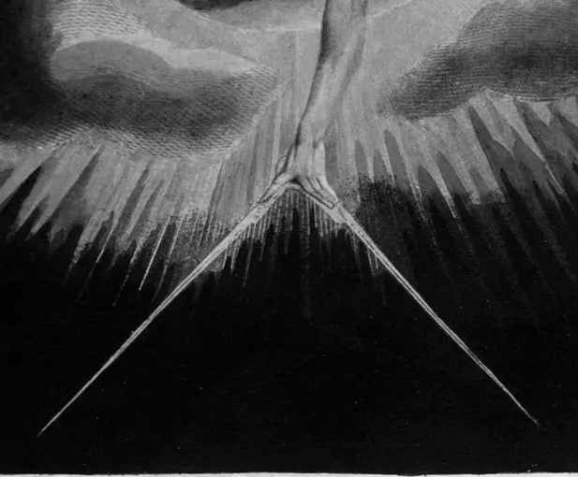
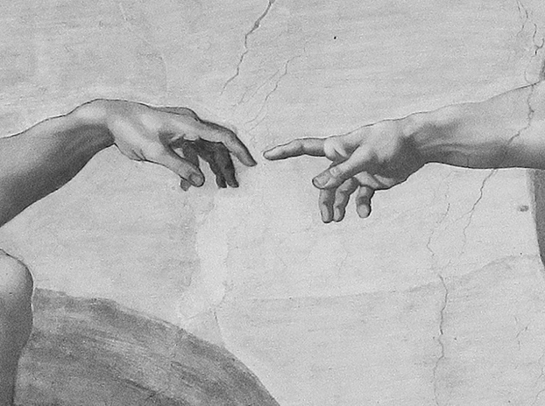

Absence has a strange way of altering belief. He is here, but He is not there. He is invisible, yet He is tangible. On their podiums, one after the other, they would say to us: “Without reliance on God, our job is impossible.” If we voiced any argument, they would clarify: “It can be thought of as the space between two fingers.” Personally, I never questioned it. A man on a podium has a better chance of reaching our minds than a man in the sky. But, it seemed, a man in the sky has a better chance of reaching our hearts than the man who stands on the podium. They are constantly invoking Him, but they never pay their dues: in great halls, in front of greater crowds, they either select a few faces to look at in turn or fix their gaze on the back wall. Have you ever seen even the greatest speaker look up?

The jazz singer had her eyes closed, whispering Billie Holiday’s I’ll Be Seeing You to the atrium of a half-empty art gallery. I recognised her from a few of the clubs uptown: Sonata, The Egg. She was known for being overfriendly with her audiences. Tonight, her face was sharpened with contempt; and without her band, there was silence between her words. Instead of her usual black satin slip, the event organisers had dressed her up in a red-feathered gown that made it difficult to separate her from the exhibits. Either it was of poor quality, or the gown must have been designed to moult over time: red feathers littered the stage.
Perfect for a Surrealist exhibition, either way.
I turned around to resume my study of René Magritte’s L’Assassin menacé, a favourite painting of mine, trying — not for the first time — to figure out whether there is any remorse in the assassin’s eyes. At a glance, they can seem wholly indifferent, although closer scrutiny always reveals a latent melancholy. However far I get, when the rest of the painting is taken into account, his eyes become less interesting.
The first thing that strikes me about this man is that he is clearly caught between two states of mind. One: the sudden absence of motive; and, consequentially, two: a new awareness of the presence of music. His gaze is fixed on the horn of a gramophone. Whatever task he has been set, he has wavered from it: his jacket and hat are off, draped over a chair; they have been hastily discarded, his briefcase similarly abandoned beside him. Behind him, on a divan, lies the pale corpse of a naked redhead, a thick dribble of blood leaking from her mouth. A white towel has been draped across her collarbones, covering part of her throat. At first, I think she must have been relaxed when the assassin took her life, reclining on the divan, listening to a record. But when I look closer, the only part of her body that isn’t rigid is below the knee of her left leg. The whole situation begins to look more and more like an arrangement. A setup! Sometimes I feel the need to question this further; but this time, it doesn’t seem important. Hiding behind the partition are two bowler-hatted heavyweights with truncheons and nets. Apathy, underlaid with quiet intent, lines their faces. Three more bowler-hatted heads rise from behind the balcony rail, their arms pinned by their sides. Behind them, mountains. The assassin is surrounded: they are waiting for the right moment to arrest him. By taking his hat off, he has successfully –– in their eyes –– renounced himself, removed any affiliation with them, and welcomed their wrath. But they are undecided: he has already been arrested by the music from the gramophone.
“There are seven bowler hats in total.”
A woman. Irish. I did not turn to match the voice with its face.
“Seven? I only count six.”
“Give it time.”
A brief silence. Northern Irish.
“You know this painting has been doctored? The original shows three hatless men behind the balcony rail. And the main subject’s hat, discarded hastily onto the chair, should be of a markedly different style, not identical to his captors’.”
In contour and intonation, her words were a disquieting reflection of my thoughts.
“It must be hard to sing in a gallery.”
A longer silence. Not from Belfast, then.
“Have you seen the Giacometti sculptures?” she asked.
“Yes.”
“Have you really seen them?”
“I didn’t come here to worship.”
The atrium was filling up with visitors; and judging by the shifting contours of the jazz singer’s voice, she had opened her eyes to welcome them:
“I’ll be looking at the moon, but I’ll be seeing you…”
The last line of the song was delivered with such intensity that I had to turn and face her. Her efforts were received with silence, despite the full seats facing the makeshift stage. She looked down at her feet, ashamed. I averted my eyes to the ceiling: a new clarity descended. The fluted columns seemed to quiver and vibrate, as if struggling to hide a fraternity of monks wobbling on each other’s shoulders. A fat, waddling figure –– man or woman, I couldn’t say –– went past the stage and into the sculpture hall, the squeak of its rubber-soled shoes applauding the jazz singer’s performance as she began her next rendition:
“I cover the waterfront…”

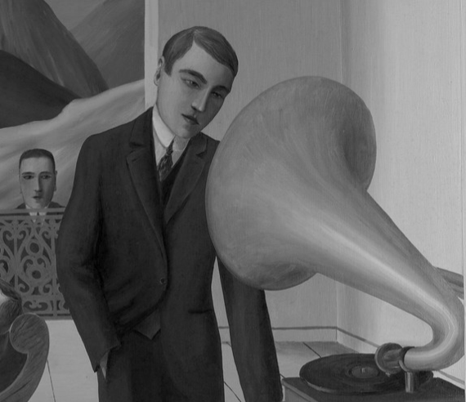
The sea was grey and apparently boundless. It irritated me. The currents were relentless. Our boat, small and without cover, somehow rocked gently. The petrol engine throbbed and spluttered. The captain, haggard and malnourished, whistled as if the sea and the engine were his bandmates. We were headed for a mass of grey mountains. They didn’t seem to be getting any closer, so I placed my bowler hat over my eyes, inhaled the warm odour of my scalp, and listened to the captain’s lisped whistle until I fell asleep.
I dreamed of a white villa, its plaster cracking. A fat, wet figure –– apparently female –– was boarding up its doors and windows. Matted carpets of soaked red feathers littered the footpath, marking where she had been. Only one door remained to be boarded. When she gave up hammering and came out onto the balcony, leaning heavily on the rail, she was quite clearly a man. There was a feeling of expectancy –– expectancy without apprehension, like a spoiled child opening her fourteenth present.
I forced myself awake. My hat slipped from my face and fell into the water. I immediately focused my attention on the captain to stop myself from dozing off again. He seemed to have whistled himself into existence. If he stopped now, that would be it: the engine would stutter and halt, the sea would give up, and we would both fall gratefully into absence.

The monks welcomed me at the mouth of a cave. They said they were followers of San Giacometti. Confused, I turned to face the shore: the captain was already firing up the petrol engine. I watched his back as the boat receded into the sea: he was well fed compared to these narrow monks. One of the monks clasped his hand around my shoulder. His skin was soft and malleable. I had the feeling that if I pressed my thumbs onto his palm, the imprint would ripple and re-arrange its lines as if I had dropped a pebble into a puddle.
They led me into the cave. I got the impression they would rather be static, but they were compelled to move by forces beyond themselves. They had the slow, lumbering movements, the soft, crooked necks, the ringed, sallow, cavernous eyes of those whom smoke had not just concealed but consumed. They lifted their arms and beckoned towards proximities beyond my sight, smiling as if they had privileged access to a world beyond this one. I began to regret my departure from their long, narrow rooms. Their smiles were so wide, so self-assured: they did not recognise me.

