Long Monday – The Fragment Through Film

Fragmentary writing’s appeal lies in versatility, unpredictability, and provocation: “one can never be sure of what exactly constitutes a fragment… [it] is hostile to meaning and resists understanding” (Elias, 2004, p. 2 - 3). That appeal led me to the following screenplay. Elias continued, referencing the use of repetition and resolution, “writing expresses an attempt at finding a language which [can] accommodate the fragment and at the same time be appropriate [for it]” (p. 118). My language is film. I believe the fragment, while primarily a literary identity, can be married with screenwriting and subsequently, cinematic language. To accomplish this, I laid my focus upon various formal elements that can contribute to a variety of fragmented signifiers, such as flashbacks, distinct framing, back-and-forth character dynamics, and varied cinematic styles. I opted for the use of repetition regarding how the scenes are visually composed in the reader’s mind to further emphasise Long Monday’s (LM) fragmentary nature. Beyond that, the interspersing of critical analyses within the screenplay contributes to its fragmentation outside of the diegesis.
Formal repetition mirrors the protagonist’s life. It is intruded upon, albeit in different fashions. The screenplay presents this by attempting to engage with ‘mosaic’ and ‘bricolage’ interpretations of the fragment: playing with flashbacks, nonlinearity and “heterogeneous materials” (2019, p. 11), which provide a diversity amongst those interpretations. This was primarily achieved through shot types, dramaturgical elements and scene compositions.
Furthermore, freedom of definition afforded to me was important. It gave me the confidence that this fusion might work, “since fragmentary writing is not a widely established category, the list of its distinctive features has not been authoritatively codified” (Guignery and Drąg, 2019, p. 12). It’s a malleable form of literature, therefore a malleable form of writing which in theory can be moulded further into another form.

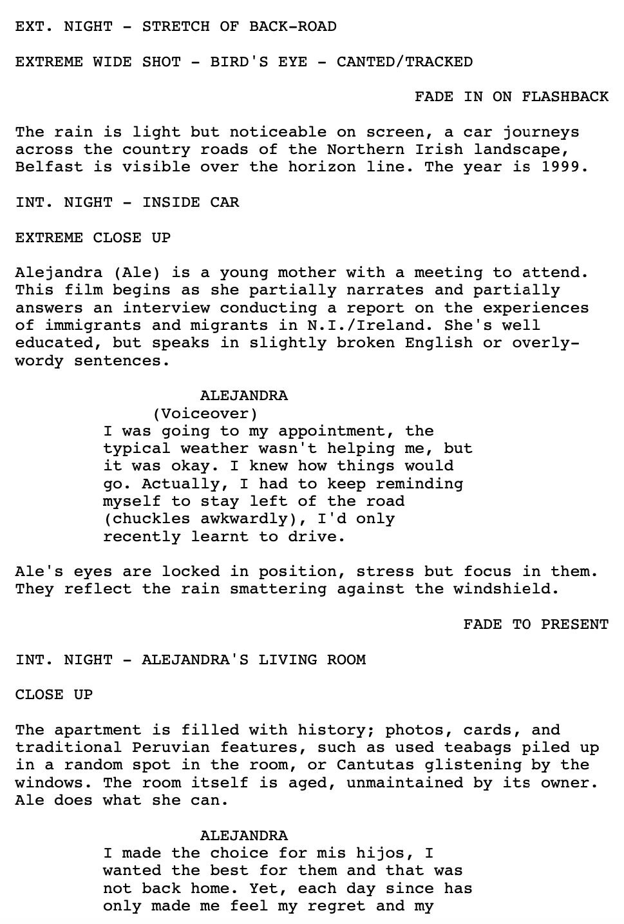
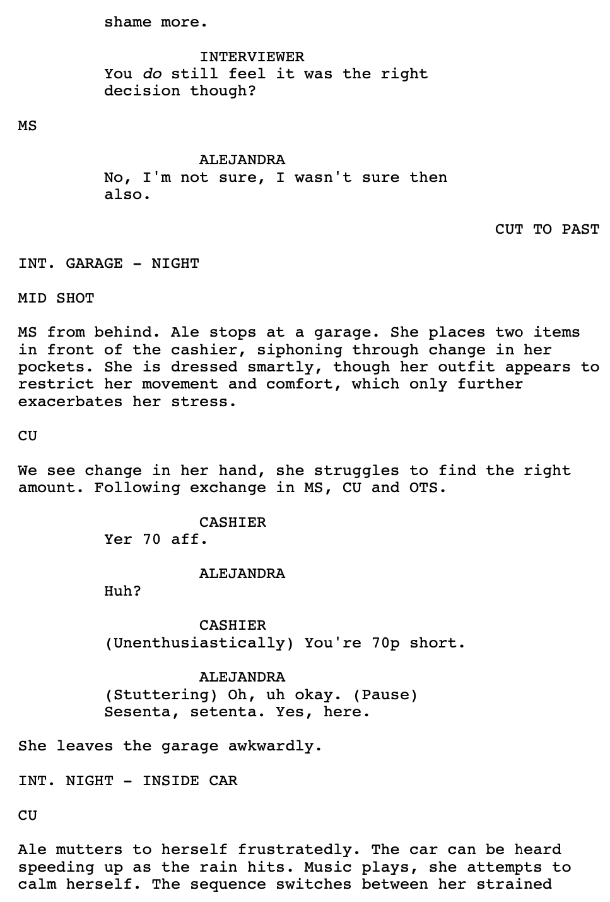
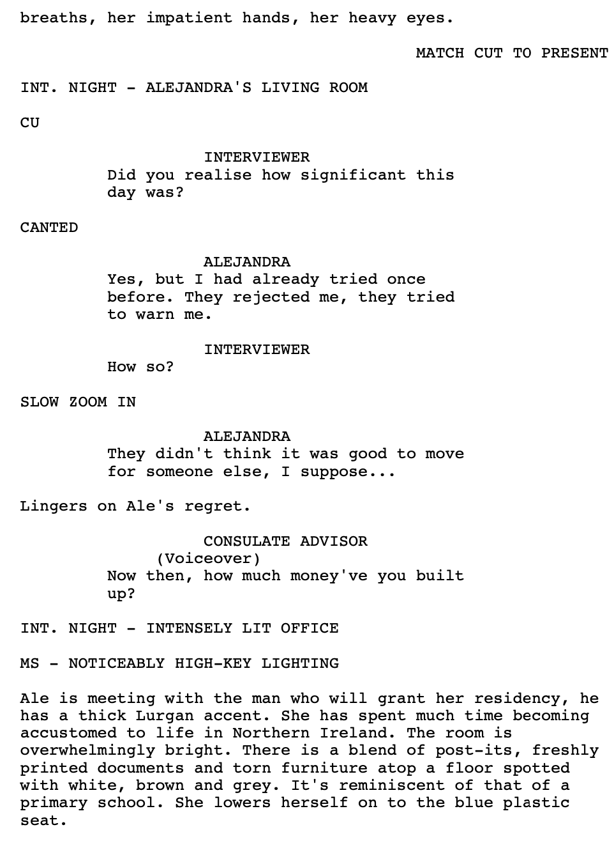

Montage elements (pages 4 & 5) are pivotal to the fragment here, as is the disparity between the presentation of the past and present. Tension is not limited or confined to the script, it extends to Alejandra’s home, personal, work and social lives.
LM works as both a short and a segment. Moseley underlines this feature, citing Gioia’s comparison of older and contemporary works, “[fragmentation was relied on] as a means of disjunction and dissolution… the new novel is holistic and coalescent” (p. 8). I wrote my characters so the reader could imagine them in an extended piece and beyond (done through cultural signifiers or specific dialect choices, e.g. pages 1 & 4). Focusing on ‘bricolage’ works, he emphasised the importance of “very disparate materials” (p. 11), with examples ranging from newspaper clippings, Indian sex manuals and sheet music. While I was unable to accumulate such provocative materials, I thought it appropriate to channel these fragmented features through vastly differing stylistic scene compositions - the natural lighting and faux-documentary nature of the present interview scenes contrast intensely with the consulate interview, with its burning high-key lighting and high intensity editing. Additionally, the chiaroscuro-style flashback on page 9 between Ale and her partner, or the warm, dreamlike depiction of the past on pages 5 & 6. Then through different shot types and camera manoeuvres/movements, along with the various narrative/set directions (voiceovers, blocking), comes a very starkly arranged set of stylistic juxtapositions, developing its fragmentary identity.
Structural fragment serves emotional fragment. The writing expects to sacrifice “irony and playfulness” for more serious subject matters by “[incorporating] “‘raw’ material, seemingly unprocessed, unfiltered, uncensored” and [obliterating] the distinction between fiction and non-fiction by frequently absorbing auto­biography and criticism” (p. 17).
I didn’t want to sacrifice the dark playfulness emblematic of Irish culture, so I kept awkward jokes regarding conflict and poorly timed laughs in the dialogue (page 6). I also sought to blur the fiction/reality line through documentary elements, while fictionalising experiences I had/could draw from. As well as personal inspiration, I studied an array of films, such as Neil Jordan’s Angel (1982) or Melina León's Canción sin Nombre (2019).
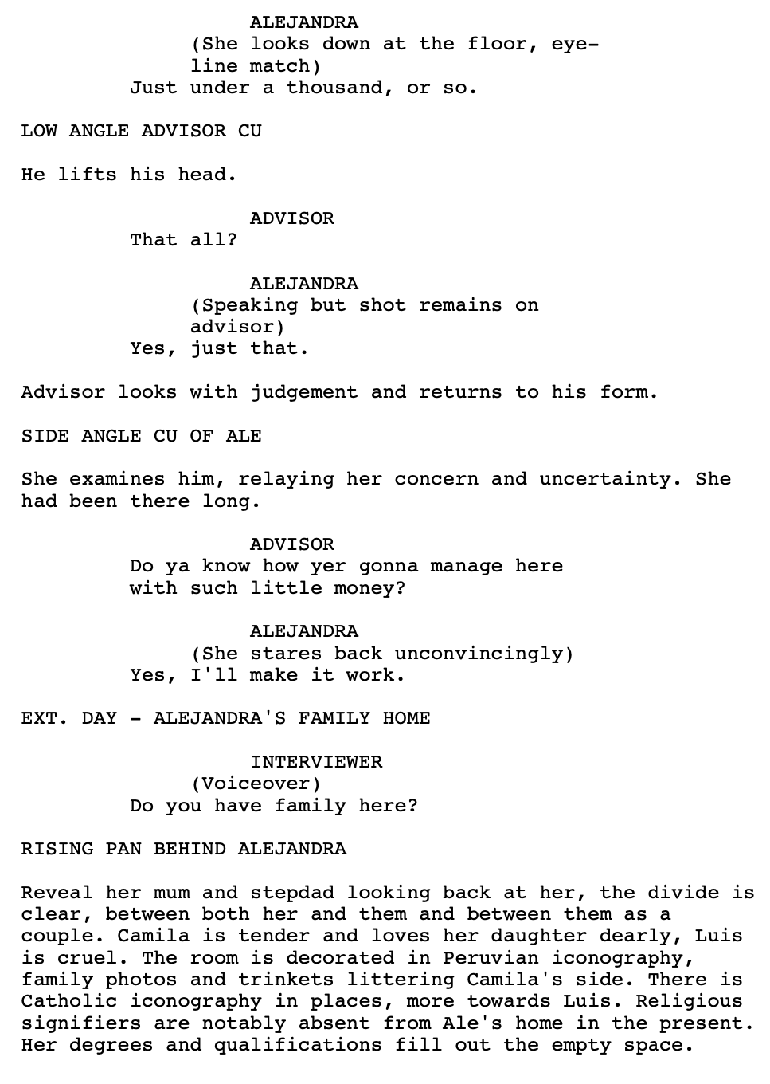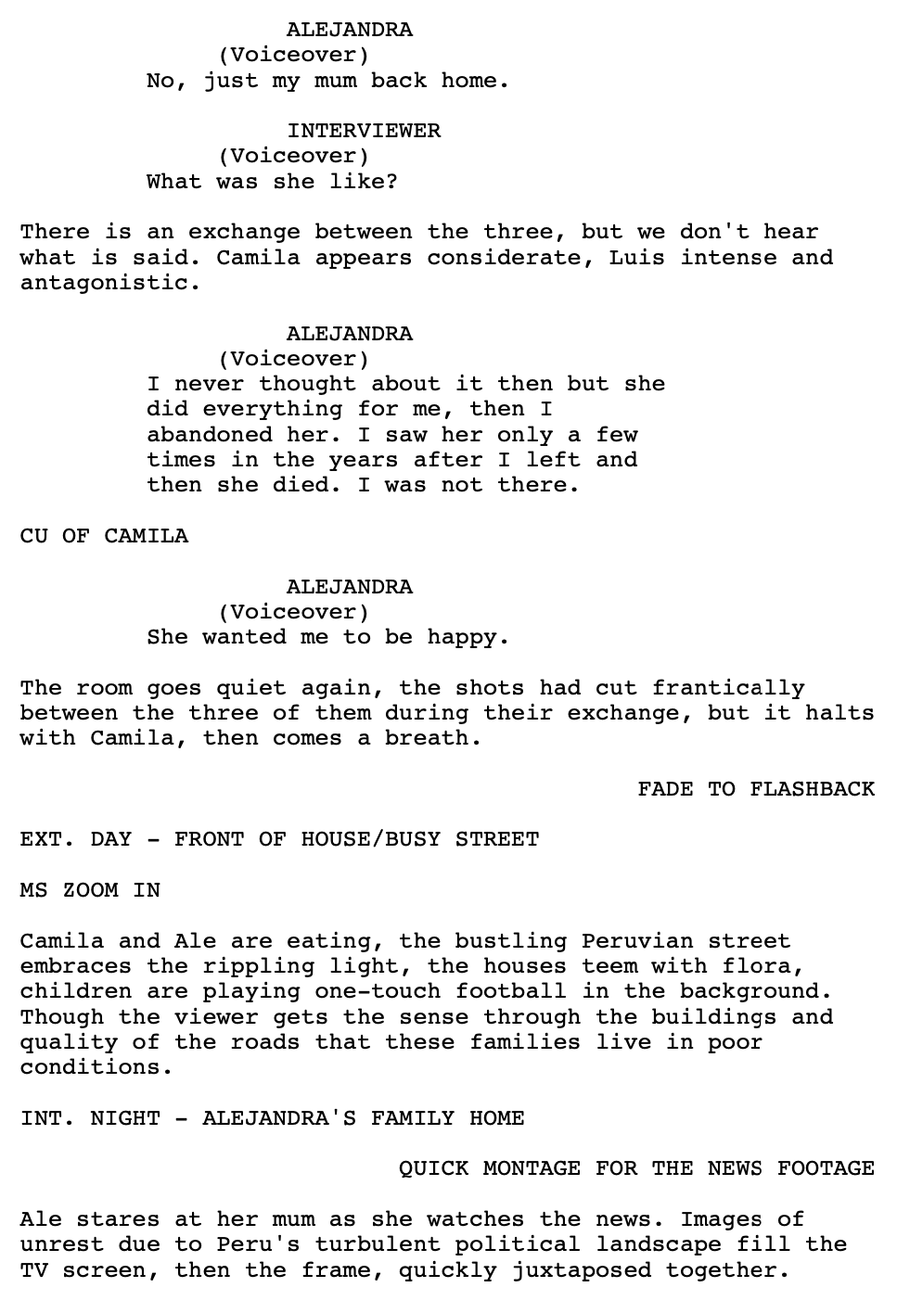
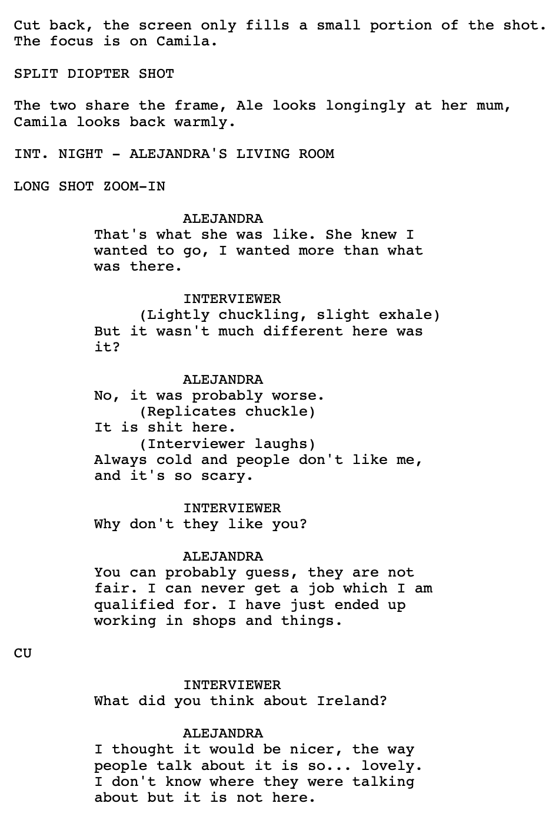
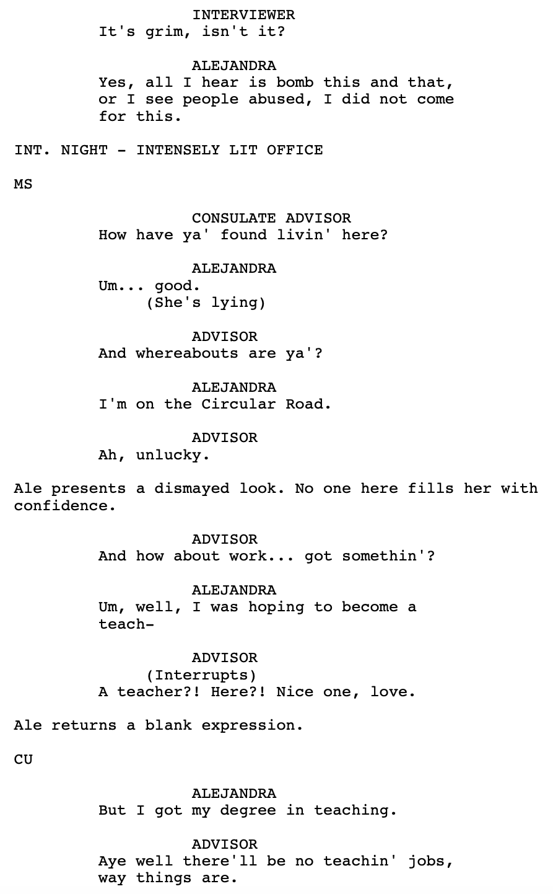
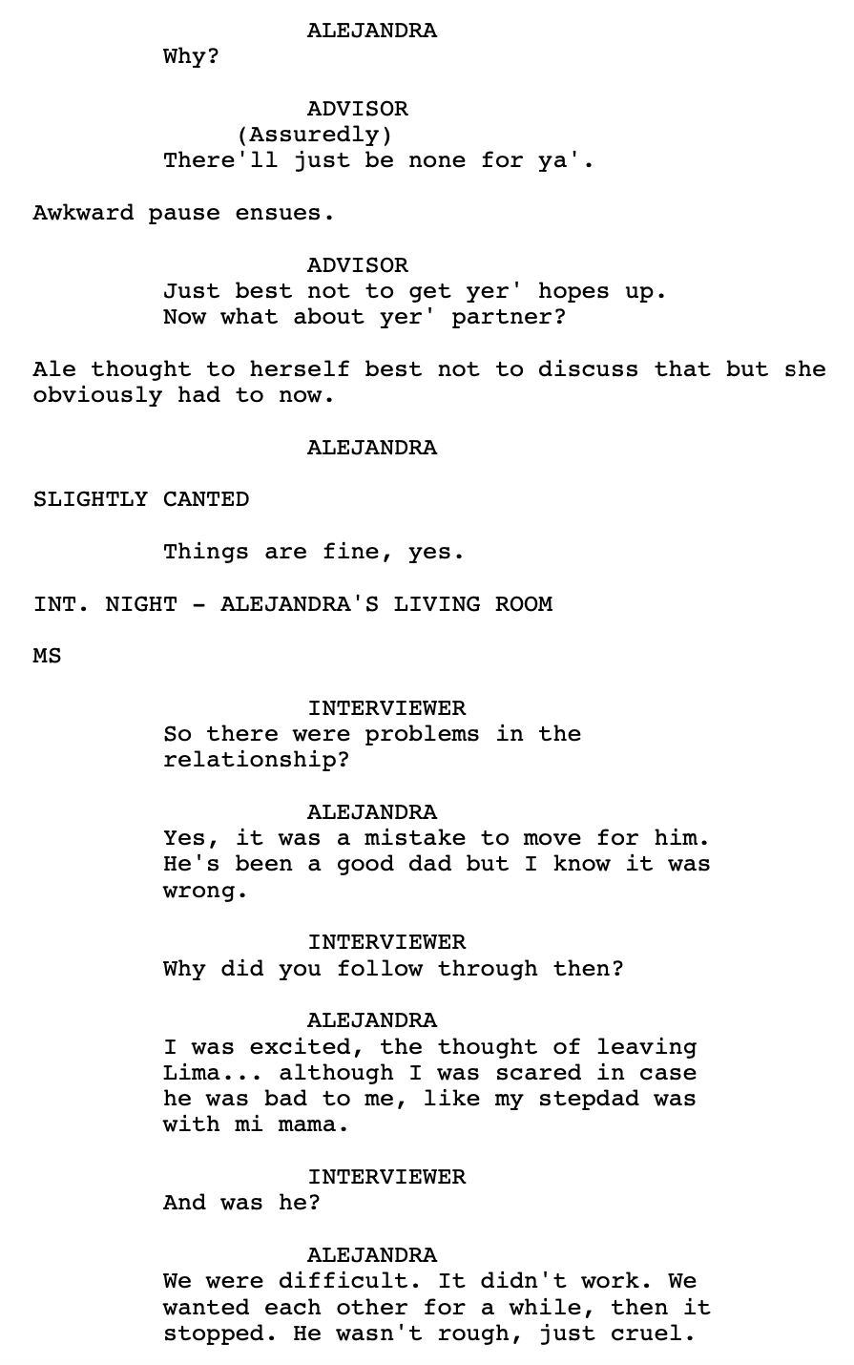
Moyer on ‘nonfiction film fragments’: the importance of capturing them and understanding them in isolation and as a whole. “The film fragment frustratingly makes us aware of the larger life/world of which it is a remnant - the lived life of which the face is a glimpse” (2007).
The majority of the emotional fragment lies there, the dichotomy between a Peru with no promise, and a disappointing and socio-politically fraught Ireland. Alejandra is owner to geographical fragmentation, emotional fragmentation with her loss of identity and her failed relationship, as well as being the subject of a structurally fragmented script. Studying Chinese-Indonesian independent filmmaker Edwin, writer Teo Miaw Lee discussed the ‘accented filmmaker’, which defines “exilic, diasporic and post-colonial filmmaking”. Quoting Iranian American theorist Hamid Naficy, he presents production practices that create a ““structure of feeling”, speaking not only to hybrid identity and a sense of in-betweenness, but also encoding cinematic practices in terms of the particular socio-political context” (p. 3115). While LM does not exist for production purposes, it was written as if it did. Its hybrid identity lives in not only its multitude of stylistic identities, but also its role within this critical reflection.
Miaw Lee continues, “[accented production] encourages the development of an accented and de-territorialised style, driven by its own limitations… by smallness, imperfection, amateurishness, and lack of cinematic gloss… also characterised by textual richness and narrative inventiveness” (p. 3117). It speaks to Guignery and Drąg’s descriptions of lack of wholeness/completion. LM isn’t only small, limited and built upon technical imperfections, but also centres imperfect individuals. Then, considering the narrative structure that is played with, there’s a clear relationship, or potential for a relationship, between fragmented writing and cinema through the accented filmmaker.
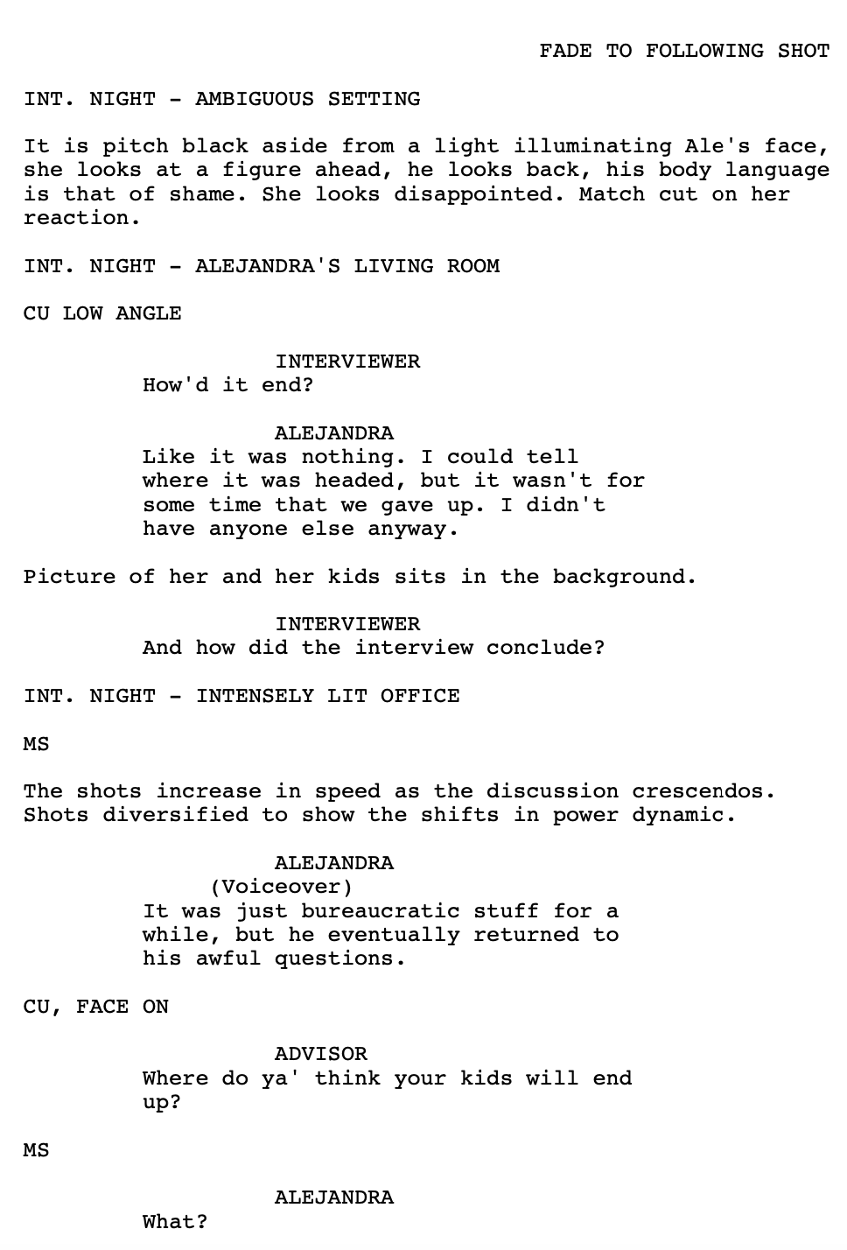
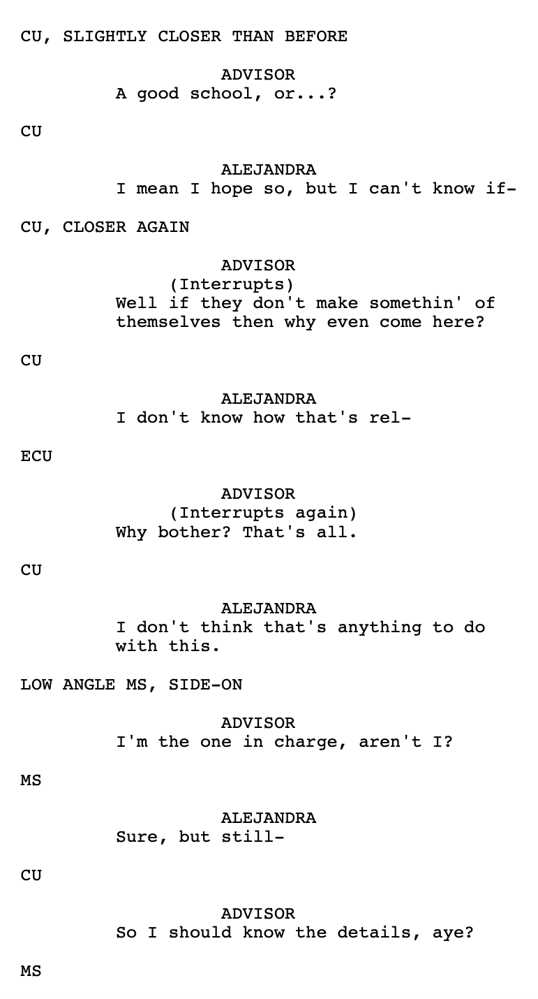

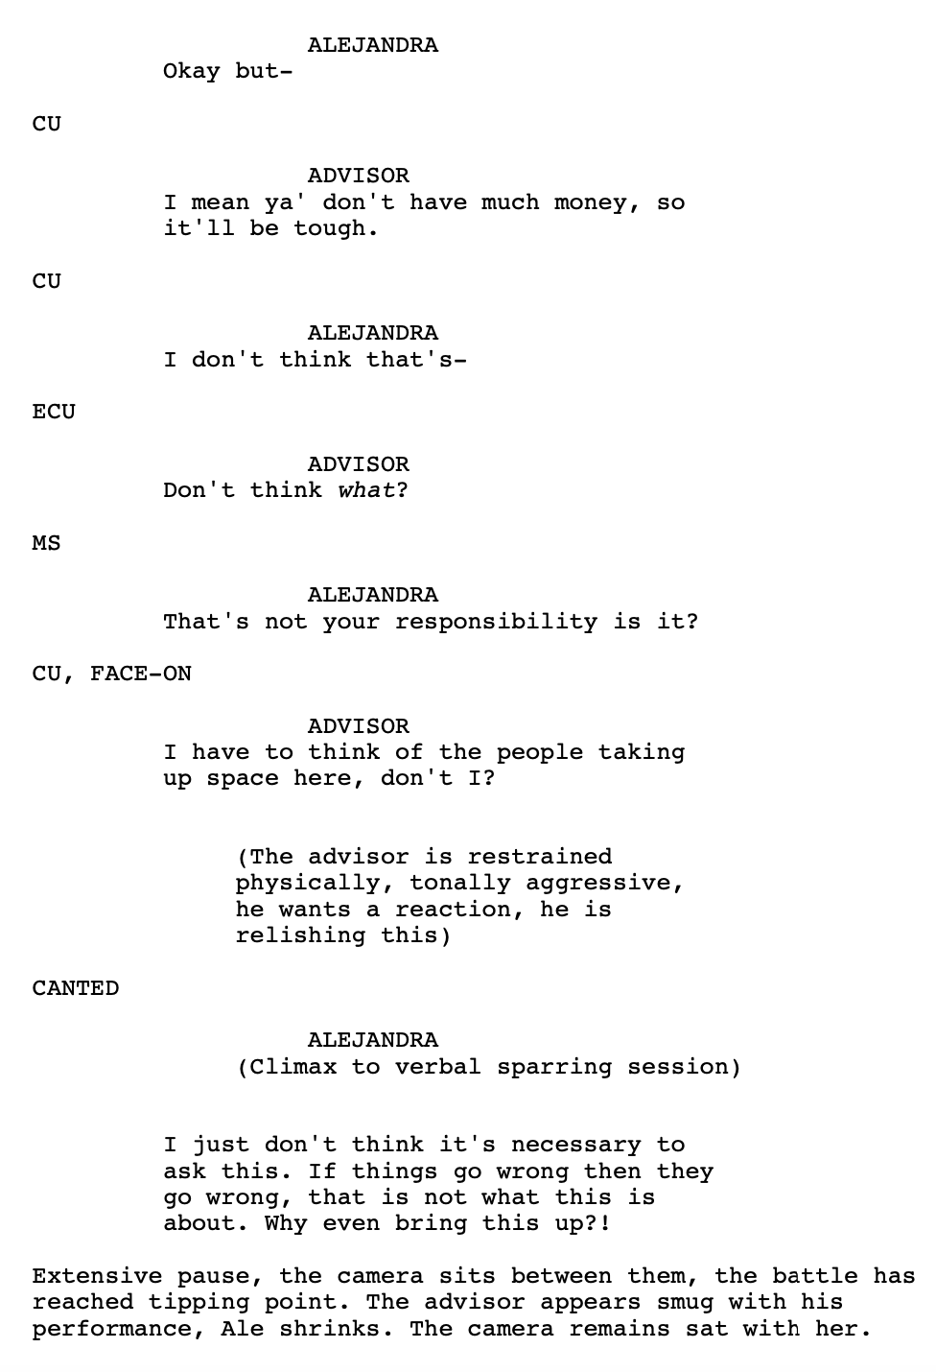
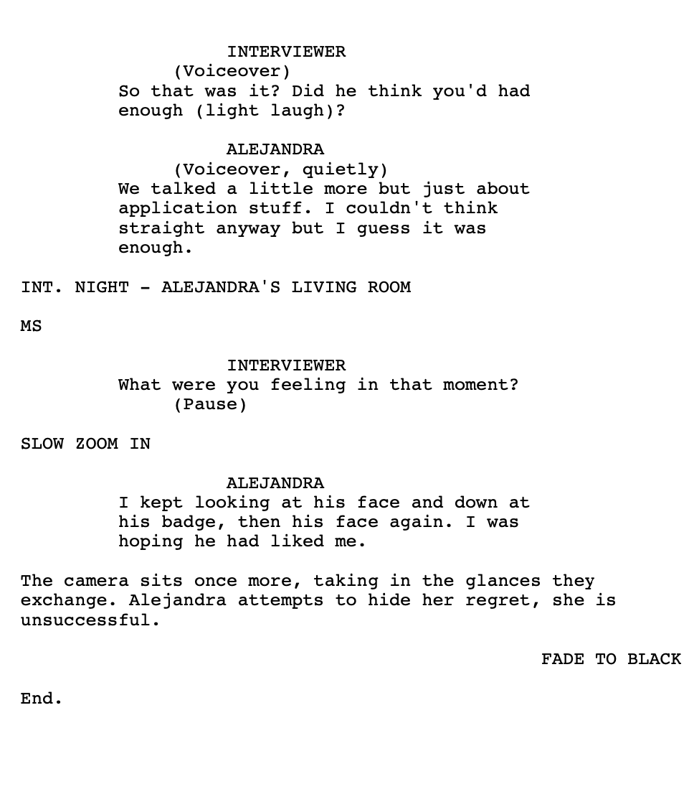

Bibliography:
- Elias, C. (2004). The fragment: Towards a history and poetics of a performative genre (Vol. 112). Peter Lang.
- Guignery, V., Drąg, W. (2019). The Poetics of Fragmentation in Contemporary British and American Fiction. Vernon Art and Science Inc.
- Jordan, N. (1982). Angel [Film]. Bórd Scánnon na hEireaan, Channel Four Films, Motion Picture Company of Ireland.
- León, M. (Director) (2019). Canción sin Nombre [Film]. Peru: Una Vida Misma Films, LaMula Producciones.
- Moyer, J.F. (2007). Film and the Public Memory: The phenomena of nonfiction film fragments. Contemporary Aesthetics, 5(1), p.13.
- Naficy, H. (2001). An accented cinema: exilic and diasporic filmmaking: Princeton University Press.
- Shields, David. (2010). Reality Hunger: A Manifesto. Knopf.
- Teo, M.L. (2019). Fragmentation and Displacement: Edwin’s Accented Film Practice. International Journal of Scientific & Technology Research, 8(12), pp. 3115-3121.

